**Protocol**

**Fertilizer response trials to validate AKILIMO for potato in Rwanda (Season 2021 B) (SA-VAP-1)**

** **

** **

1. **Introduction**

AKILIMO is a digital fertilizer recommendation service that has been developed by the International Institute of Tropical Agriculture (IITA) to provide tailored, site-specific fertilizer recommendations to cassava farmers in Nigeria and Tanzania. AKILIMO can generate fertilizer recommendations based on various levels of spatial targeting (e.g. from subnational level to farm or plot level) and farmer-provided information (e.g. previous yield and maximum amount to invest in fertilizers) to replace blanket fertilizer recommendations. In the Scaling AKILIMO project (funded by the CGIAR Research Program on Roots, Tubers and Bananas), IITA, the International Potato Center (CIP), The Rwanda Agriculture and Animal Resources Development Board (RAB) and One Acre Fund (OAF) have engaged in a partnership to expand AKILIMO to a new geography (Rwanda) and a new crop (potato).

During the 2021A Season in Rwanda, fertilizer response trials with 6 treatments, varying in N, P and K ratios and rates, were conducted to gather the necessary data to calibrate and cross-validate AKILIMO models for potato in Rwanda. Following this exercise, the performance of the calibrated AKILIMO models is now sufficiently satisfactory to start generating site-specific fertilizer recommendations for potato in Rwanda. In this protocol, field trials are proposed to validate these site-specific recommendations under on-farm conditions together with farmers.

1. **Objectives**

The objectives of the trials are to: evaluate under on-farm conditions whether site-specific AKILIMO fertilizer recommendations lead to higher revenues in potato production systems than the blanket fertilizer recommendation.

**These validation trials** will be conducted within farmers’ own fields, to evaluate the performance of the tool under farmers’ practice (real life test). While conducting trials, data is collected by the Extension Agents (EAs) and the households, with training support by the researchers

1. **Locations and timing**

The trials in growing season of 2021B will be implemented in two districts, Rubavu and Rutsiro. These two districts represent two main agro-ecological zones where potato is grown in Rwanda (Volcanic Plains and Congo Nile Divide). The trials will be conducted during the 2021 Season B.

**Site and farmers selection**

Validation trials will be established in 30 sites per district[1].

**These validation trials** will be conducted within farmers’ own fields, to evaluate the performance of the tool under farmers’ practice (real life test). As for validation, data is collected by the Extension Agents and the households, with training support by the researchers.

Geo-spatial analysis was conducted to select sites that are representative of climate, soil and other agro-ecological characteristics of the area covering the two districts. Clusters of areas with similar agro-ecological characteristics were determined (Figure 1). Sites were then optimally distributed among these clusters. The following climate, soil and land covariates were considered:

* Climate data (various layers related to temperature and rainfall)
* Soil information (various layers generated by AfSIS for different soil parameters)
* Remote sensing products (Vegetation index, MODIS reflectance,…)

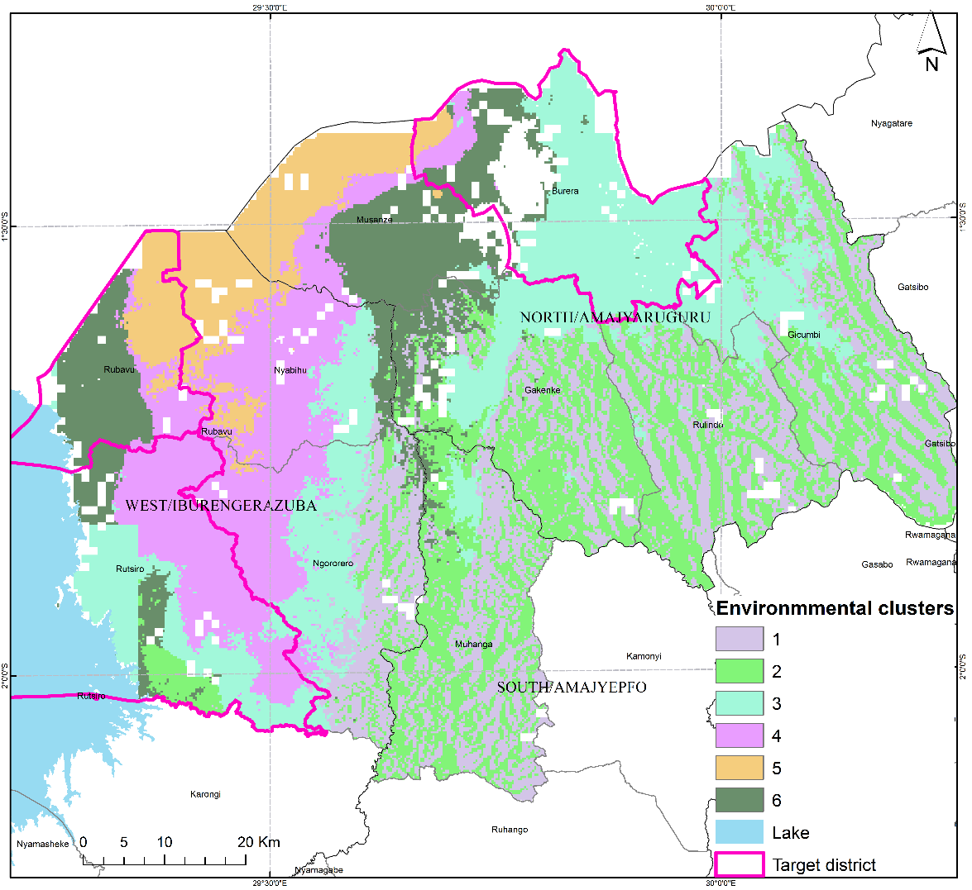

**Figure 1: Target districts with environment clusters.**

Based on these clusters, five cells where potato is commonly grown were selected per district (Table 1). In each cell, five farmer fields will be randomly selected for the trials. Hence trials will be conducted in 5 cells per district and 5 trials per cell resulting in 25 trials per district. Maps of each selected cell will be provided with random locations within cell, to maximize the representativeness of the trial locations.

All validation trials will be located across 2 districts.

|  |  |  |
| --- | --- | --- |
| Districts | Number of trials | Number of extensions agents to assist farmers* |
| Rubavu | 30 | 3 |
| Rutsiro | 30 | 3 |

**\*Each extension staff can assist 10 farmers**

**Table 1: Cells selected for the trials**

|  |  |  |  |
| --- | --- | --- | --- |
| **District** | **Sector** | **Selected cell** | **Environment cluster** |
| Rubavu | Bugeshi | Hehu | 5 |
| Mudende | Kanyundo | 5 |
| Busasamana | Kageshi | 6 |
| Kanzenze | Nyamikongi | 5 |
| Kanama | Nkomane | 4 |
| Rutsiro | Ruhango | Gihira | 4 |
| Nyabirasi | Mubuga | 4 |
| Manihira | Muyira | 4 |
| Rusebeya | Mberi | 4/3 |
| Mukura | Kagano | 3/4 |

For selecting farmers/fields, attention should be paid to the following criteria

1. The farmer should be willing to host the trial and have project staff and extension staff come to her/his farm for observation and data collection;
2. Located within 5 km from the base of operations of the EA
3. The farmer should be willing to provide land and labor for establishing and managing the trial;
4. The farmer should be an experienced potato grower;
5. The field should be located in an accessible area to allow frequent field visits;
6. The field should be sufficiently large to accommodate a field plot of 2 plots arranged in a 2 x 1 rectangle (6.8 x 12.1 m, see Figure 2);
7. The field should have been cultivated by potato at least once in the last 3 seasons, with preferably another rotation crop than potato in the last season;
8. Soil fertility should be uniform throughout the field plot considered for the trial to avoid confounding effects of within-field soil fertility variability. The following visual indicators should be used to check for soil fertility uniformity in selected fields when deciding on where trial plots should be positioned:

* The field plot should be one ‘management unit’ that has been managed homogeneously in the past by the farmer (the cultivation history for at least the last 3 years should be the same for all parts of the field plot). This should be verified by asking the farmer to identify areas of uniform management on their farms, considering management practices in the previous three years including fertilizer and manure application and crops grown.
* Assess uniformity of vegetation growing in the field plot (crops during the growing season or weeds in uncultivated fields).
* Check for uniformity of soil physical characteristics within a field plot including soil texture, colour, drainage, compaction and elevation.
* There should be only gentle slope in the field.
* There should be no areas of discontinuity, including termite mounts or soil conservation structures, such as contour ridges (this excludes commonly used mounds or planting ridges).

1. The plot should not be at high risk of animal destruction and theft.
2. The area selected for the trial must be sufficiently distant from border structures (hedges, trees, contour ridges,…), and either be located within an existing potato field, or surrounded by 1-2 border rows of potato to minimize border effects on crop performance in the net plots.
3. **Treatments and experimental design**

Two plots, one with a Site-specific AKILIMO recmmendations and one with the current blanket recommendation will be tested in each of the fields.

All fertilizer treatments will be applied in two split applications: half at planting and half during weeding and earthing up at around 4 to 6 weeks after planting.

**Table 2: Best-bet fertilizer recommendation and blanket recommendation to be tested in the trials**

|  |  |  |  |  |  |  |  |
| --- | --- | --- | --- | --- | --- | --- | --- |
| **Plot** | **Description** | **Rates per ha** | | | **Ratios between nutrients** | | |
| N | P | K | N:P | N:K | P:K |
| **Control (blanket recommendation, BR)** | Current recommendation:  6 bags/ha of NPK 17:17:17 | 51 | 22 | 42 | 2.29 | 1.20 | 0.53 |
| Site-specific recommendation (SSR) | Rate depends on the site |  |  |  |  |  |  |

1. **Trial establishment and management**
   1. **Land preparation**

A planting date will be scheduled with each farmer and land preparation will be done by the farmer before the scheduled planting date. Planting will be done on flat for all sites.

* 1. **Field layout**

At the date of planting, the trials will be established by the farmer(s) with a help from extension agent.

Each plots will be measured of 4.8 x 4.8 m equalling 23 sqm per plot. A distance of 0.5 m will be maintained between plots (Figure 2), and 1 m between the trial and other crops.

Each of the two plots will have a plant density of 96 potato plants, planted in 6 lines spaced 80 cm apart and 30 cm between plants in the same line (Figure 3).



**Figure 2: Example of trial layout**



**Figure 4: Plot layout with potato plants**

The treatments will be randomly allocated to plots, and plots will be labelled using bamboo signs. **Variety and source of seeds**

The trials will be established with certified seed potatoes multiplied by RAB. The most commonly grown varieties in the target districts will be used (Table 3).

**Table 3: Varieties to be used in the trials**

|  |  |
| --- | --- |
| **District** | **Variety** |
| Rubavu | Kinigi/ Kirundo |
| Rutsiro | Cruza |

* 1. **Fertilizer application**

Furrows will be made along the planting lines to apply fertilizers. Farmers will be given the possibility to apply organic inputs (manure or compost) and/or lime according to their usual practice before application of mineral fertilizers. The organic manure should be equally distributed across the furrows and different plots.

Mineral fertilizers will be applied by research staff both at planting and top-dressing (at earthing up at around 4-6 weeks after planting). One small bag per plot with the right quantities of pre-mixed fertilizer will be prepared before planting and the fertilizer in the bag will be equally distributed across the furrows in the plot (adding to the organic manure if it is applied). Fertilizers will be covered with soil before planting the tubers. Table 4 provides an overview of the quantities to be applied per plot and time of application.

**Table 4: Quantities of fertilizer per plot**

|  |  |  |  |  |  |  |  |  |  |
| --- | --- | --- | --- | --- | --- | --- | --- | --- | --- |
| **Plot** | **First application (at planting)** | | | |  | **Second application (at earthing up)** | | | |
| **NPK 17:17:17** | **Urea** | **DAP** | **MOP** |  | **NPK 17:17:17** | **Urea** | **DAP** | **MOP** |
| g/plot | | | |  | g/plot | | | |
| **Blanket recommendation (BR)** |  |  |  |  |  |  |  |  |  |
| Site-specific recommendation (SSR) |  |  |  |  |  |  |  |  |  |
| Total quantity needed for …… trials (kg) | 173 | 9 | 9 | 9 |  | 173 | 9 | 9 | 9 |

* 1. **Planting**

After fertilizer application, seed potato tubers will be planted in the furrows spaced 30 cm apart, using a rope with 30 cm spaced marks. The furrows will then be covered with soil. For each plot, 96 tubers will be needed for planting. The number of tubers needed per trial is 192 (approximately 20 kg), and the total number of tubers needed per district (25 trials) is 4,800 (approximately 500 kg).

* 1. **First weeding and earthing up**

First weeding and earthing up will be done at around 4-6 weeks after planting in the presence of Extension agent, and the extension agent will help a farmer to apply the second dose of fertilizers.

* 1. **Field management**

Apart from fertilizer application, farmers will manage the plots according to their usual practice. Weeding, pesticide application and other pest and disease management will be done by the farmer according to their common practice and at their own cost.

1. **Field visits and data collection**

Each site will be visited by extension agent at least 5 times during the season, inclusive of the planting and harvest date.

All data collection during the trial will be done electronically using tablets and ODK forms (overview in Table 5). Tablets will be provided by CIP. However, two copies of a paper Fieldbook will be kept by the responsible Extension agent, and by the farmer, to record data on trial management in the absence of Field Officers.

**Observations**

For each validation trial, a very simple evaluation booklet will be provided to collect the bare essential data by the participating farmer and the supporting EA. This booklet will be translated into local language (if necessary), to facilitate understanding by the participating farmers. The data collected by the participating farmers themselves will capture details on the management of the land and the crop (method of land preparation, time of planting, time of weeding, etc…) with the support of the EA in each of the villages. The extension agent will assist the farmers to complete the evaluation booklet and will be responsible to ensure trials are correctly executed. Data captured will be entered in a dedicated ODK form (“Validation of Site-Specific Fertilizer Recommendations – Data Collection”) by the EA. The EAs will be equipped with smartphones or tablet and hanging balances, and will be trained to apply the ODK tools and conduct (timely!) data collection.

**Data to be collected include:**

1. General information on the household, using the ODK form “Register HH” when providing the participating household with a HH-ID card).
2. Information on land preparation
3. Date of planting and crop management operations (especially weeding)
4. Quantities and timing of fertilizer application
5. Plant stand
6. Trial monitoring by EA (scoring for various criteria)
7. Yield assessment (at the time of harvest decided by the farmer)

The research partners will conduct a monitoring visit to evaluate if trials were correctly implemented. Data captured will be submitted through an ODK form. This form will guide the scoring for various criteria (correct implementation, border effects, heterogeneities, damage,…) and make a judgement on the validity of the data collected in the trial (yes / maybe / no).

**Action plan**

Various steps need to be taken in order to have the validation trials installed timely. Close coordination, good communication and clear establishment of roles and responsibilities between the different partners are essential to ensure successful execution of the trials.

**Activity 1 – Establish teams**

Local teams of researchers, students, development workers and extension agents that will be involved in the activities (per cluster) need to be established and tasks and responsibilities agreed upon. Protocols must be discussed so that there is common understanding of all details.

Identify (a) lead agronomist(s) (RAB) per district, and extension agent(s) in each village (or set of neighbouring villages).

Agree on Roles and responsibilities:

* CIP/RAB: initial training of EAs and primary partner coordinators, overall coordination and overview of implementation of the exercise, organize review meetings, visit subset of the fields to ensure everything is done correctly, train on data collection, ensure quality of data.
* Extension agents: day-to-day interaction with farmers, execute the field visits and delineating the plots within the selected fields, organize yield data collection, alert primary partners and ARI on issues, progress, changes in planned harvest dates,…

**Activity 2 – Design an incentive scheme for EAs**

A point-based reward system is designed to provide incentives for EAs to install and collect the data. A total of 9 activities is requested from the EA. For each activity, a fixed number of points are awarded.

|  |  |
| --- | --- |
| **Activity** | **Points awarded** |
| Run DST | 6 |
| Monitoring @ planting | 10 |
| Monitoring + gapping @ 4 WAP | 6 |
| Fertilizer application 1 @ 2-6 WAP | 10 |
| Fertilizer application 2 @ 8-12 WAP | 10 |
| Monitoring @ 12 WAP | 6 |
| Monitoring @ 24 WAP | 6 |
| Monitoring @ 36 WAP | 6 |
| Harvest | 40 |
| **Total** | **100** |

For each point awarded, the EA will receive 1,000 TSH. Hence, an EA can maximally earn 100,000 TSH per farmer, or 1,200,000 TSH for 12 farmers. This is equal to 44 USD per farmer, or 533 USD for 15 farmers. The total award per EA is the same for the SP validation, but the number of farmers is less (12 instead of 15) while the award per farmer is higher (100,000 TSH instead of 80,000 TSH).

To facilitate payment, a system will be put in place to indicate the date at which each data collection event needs to happen for each farmer and EA. This will be automatically generated, after EAs have identified participating farmers and run the DST (to obtain planting and harvest dates). Incoming data will be analysed and automated reports will be generated to report what data has been collected by which EA for each farmer, and the number of points awarded will be calculated. Some data quality assessments will be done (check registration, and verify consistent GPS location, farmer ID and EA ID. Payment will then be executed through the IITA office, either by mpesa or bank transfer, at the end of every month.

We normally pay farmers facilitators based on daily work and activities conducted, we use to pay 5,000frw per day work. If we work with extension agent with advanced level of education, then this amount should be increased and then paid at monthly basis-

**Activity 3 – Identify EAs and farmers**

In targeted districts, there exist farmers facilitators who have been trained by RAB to play a role of extension agents in their villages. RAB will facilitate to identify the right extension agents based on their expertise and ability to conduct trials and assist the farmers on data collection, monitoring and reporting.

Farmers must be identified based on criteria set on point 4, and must be a potato grower within a 5 km radius from the supporting EA. Shortly before the onset of the planting season, EA’s should identify farmers who have accepted to participate in the validation exercise, and confirmed their willingness to take care of the validation trials. Fields must then be visited to evaluate if these meet the necessary criteria (see above).

**Activity 4 – Training of EAs**

EAs must be trained in how to select farmers, identify suitable fields, lay out the validation side-by-side plots within existing fields, use the DST to determine the recommended fertilizer rates, ensure these fertilizers are applied timely and correctly, and follow-up and collect data. Trainings will be conducted through a training-of-trainers approach. First trainings will be led by the RAB agronomists + CIP& IITA team in collaboration with local government leader at sector level.

Discuss on how EAs will be facilitated! Proposal is as follows:

* EAs will receive a smartphone to run the tool, a t-shirt, EA ID card, a balance, a measuring tape, manuals on the use of the tool, flyer (simplified protocol), and the data collection booklet packaged in a nice branded AKILIMO + RAB” bag.
* Monetary remuneration through the award system (see above)

**Activity 5 – Prepare discussions with farmers**

RAB in collaboration with local govt. agent will facilitate discussions with farmers in the different districts to identify volunteers who will be conducting validation trials.

**Activity 6 – Translation and multiplication of documents**

The information flyer (simplified protocol) and the data collection booklet need to be translated in local language, multiplied and added to the validation packages.

**Activity 7 – Preparation of packages**

This validation exercise does not imply distribution planting material. Following materials will be provided to facilitate the exercise:

* An information folder, protocol flyer and data collection booklet.
* A knotted rope to aid in laying out plots of correct size.

Fertilizer will be supplied at the time of application, at the planting for the first split, and 6 weeks later (between 8-12 WAP) for the second split (see above). It is important that when sending out the fertilizer for application, the fertilizer is clearly marked with the name of the farmer, the name of the EA, the district, and the quantity (weight in grams) and type of fertilizer. The EA will need to confirm the weight of fertilizer applied in the data collection ODK form, hence it is important that (s)he copies the weight of the fertilizer indicated on the bags.

**Activity 8 – Training on installation, and distribution of packages**

The training should handle the following:

* Demonstration of how the validation trials must be implemented. Particular emphasis should be given to the requirements of the field (homogeneous, no trees in the middle of plots, no large trees neighbouring the plots, termite hills, etc…) and the trial should be laid out in a field that is being cropped with an improved cassava potato variety, and at a density of 417 plants are-1. Farmers should manage the land (land clearing, tillage, ridging,…) and perform weeding as they commonly do.
* Distribution of the packages. Packages should be distributed to the volunteers identified within the selected villages.
* Explanation on the terms of agreement to perform the validation exercise. All produce will remain with the farmers. The farmer decides when to harvest his field but should inform EAs before doing so, and allow EA to collect data and measure the yield in the two plots delineated within the farmer’s field. AKILIMO will provide training and share learning.
* Explanation on the role of the EA in terms of technical support, and a schedule for follow-up and monitoring by the EA and research teams.

**Activity 9 – Validation exercise installations**

The farmers now establish the plots side-by-side within the fields planted with the seed purchased from the QDS entrepreneur, with the support of the EA.

**Activity 10 – Follow up on installations**

It is important that the EAs move around to check whether activities are implemented as planned and to ensure that the implementation is happening correctly. EAs will be supported by teams of researchers to conduct this activity.

**Activity 11 – Data collection by EA**

Extension Agents are required to collect data on each of the validation exercises. Reports will be generated to EAs on when data collection events are due. Data collection should be done using the ODK form “Validation of Recommendations on Harvest Date – Data Collection”.

**Activity 12 – Monitoring**

Between 8 to 10 weeks after planting, a team of RAB and local govt. staff should visit each of the participants and evaluate the trial implemented. This evaluation should be done using the ODK form “Monitoring of Validation Exercises”.

**Table 5: Overview of visits and data collection**

|  |  |  |  |  |  |
| --- | --- | --- | --- | --- | --- |
| **Activity** | **Timing** | **Purpose** | **Data collection** | **Option to select in ODK form** | **Responsible** |
| Identification | Before training | Identification of EAs | List of EAs |  | RAB + local govt. |
| Training of EAs | Before site identification | Training on protocol data collection | ODK form ‘Register Enumerator’ | N/A | RAB+ CIP+ Local govt. |
| Field visit 1 | Before planting | Site identification & registration |  |  | EAs |
| Field visit 2 | Before planting | Seed and fertilizers distribution |  |  | RAB+ CIP+ |
| Field visit 3 | At planting | Trial establishment and planting |  |  | EAs |
| Field visit 4 | Around 4-6 weeks after planting | Weeding, top dressing and earthing up |  |  | EAs |
| Field visit 5 | 2-2.5 months after planting | Mid-season monitoring;  Weeds and disease scoring |  |  | RAB+ CIP+ Local govt. |
| Field visit 6 | 4-4.5 months after planting | Harvest |  |  | EAs |

**Annex: Materials needed**

Note: All materials will be provided by CIP

**Field visit 1 (Site identification)**

* Tablet or smart phone
* T-shirt,
* EA ID card
* Manuals on the use of the tool,
* Flyer (simplified protocol) and the
* Data collection booklet packaged in a nice branded AKILIMO + RAB” bag

**Field visit 2 (Trial establishment and planting):**

* Tablet/ smart phones
* Tape measure
* Plot labels
* Inputs (seeds and bags with fertilizers)

**Field visit 3 (Weeding, top dressing and earthing up):**

* Tablet/ Smart Phones
* Bags with fertilizers

**Field visit 4 (Weeds and disease scoring):**

* Tablet/ Smart phones

**Field visit 5 (Harvest):**

* Portable scale or hanging scale to measure quantities of 10-100 kg
* Portable scale to weigh sub samples (250-500 g)
* Sets of paper bags with pre-printed labels for sub samples
* Water-proof marker pens

1. The project team has agreed that RAB in collaboration with CIP will implement the trials in Rubavu and Rutsiro.